**Practical No 2**

**Aim: File Management tasks in Hadoop File System**

1. **Login to Hadoop user: hduser:udit@123**

su hduser

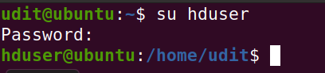

1. **Start hadoop services & verify**

ssh localhost

/usr/local/hadoop/sbin/start-all.sh

Jps

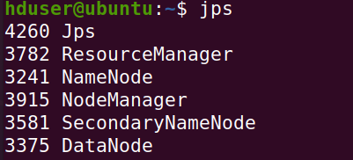

1. **Check if hadoop is installed via terminal**

hadoop version

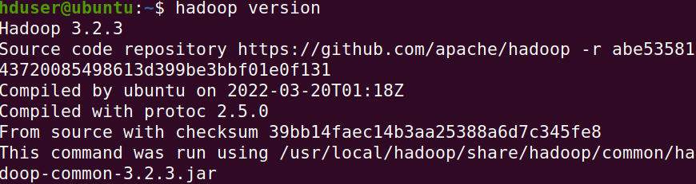

1. **Check if hadoop is installed via browser**

http://localhost:9870

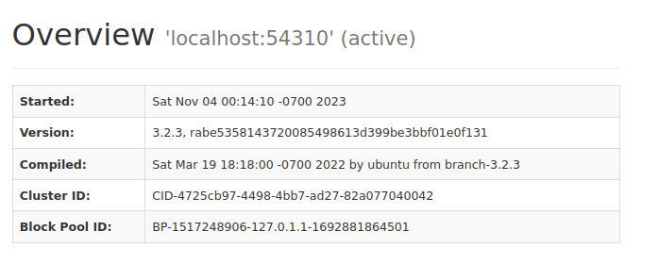

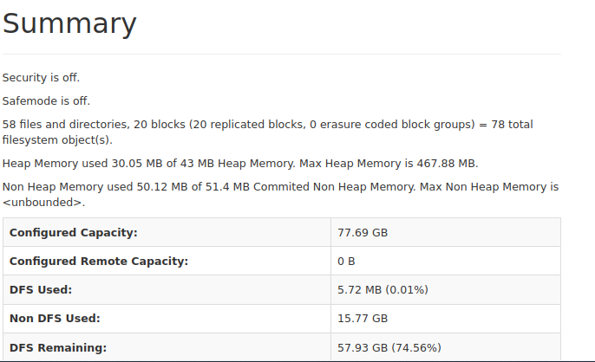

1. **Create a folder named “sds_your_roll_no” in /usr/local/ ex. Sds_a20**

cd /usr/local

sudo mkdir -p /usr/local/sds_a016

ls

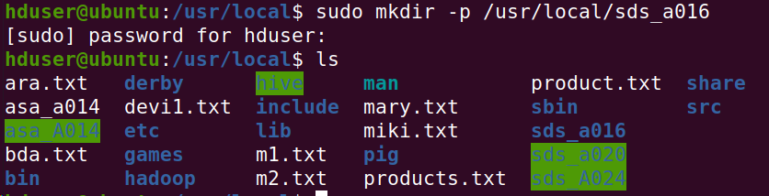

1. **Assign full privileges to sds_ your_roll_no**

sudo chmod -R 777 /usr/local/sds_a016

ls

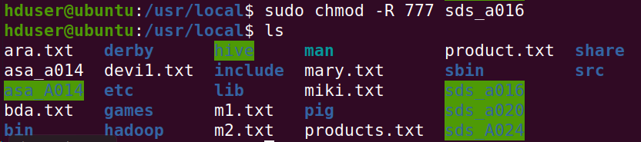

1. **Create a file named nmimstext.txt in /usr/local/sds_your_roll_no with the following text:**

cd /usr/local/sds_a016

sudo nano nmimstext.txt

ls

cat nmimstext.txt

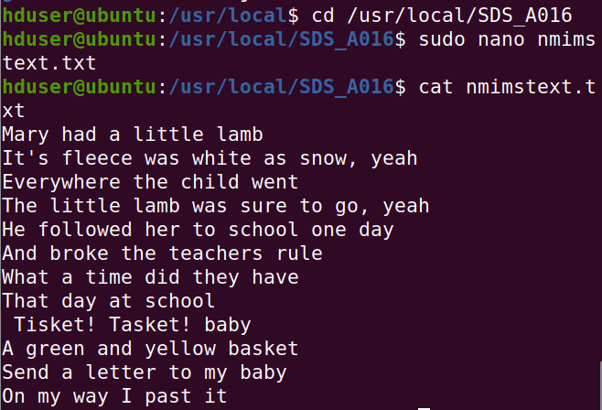

1. **Create a folder named “SDS” in HDFS root folder**

cd /usr/local/hadoop/bin/

hdfs dfs -mkdir /SDS

hdfs dfs -ls /

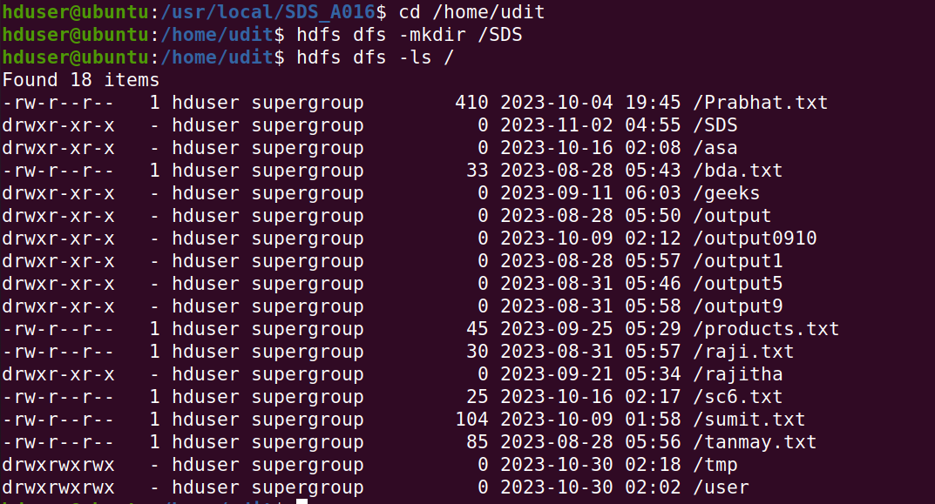

1. **Move the file nmimstext.txt to SDS folder in HDFS & verify if its moved**

hdfs dfs -copyFromLocal /usr/local/sds_a016/nmimstext.txt /SDS

hdfs dfs -ls /SDS

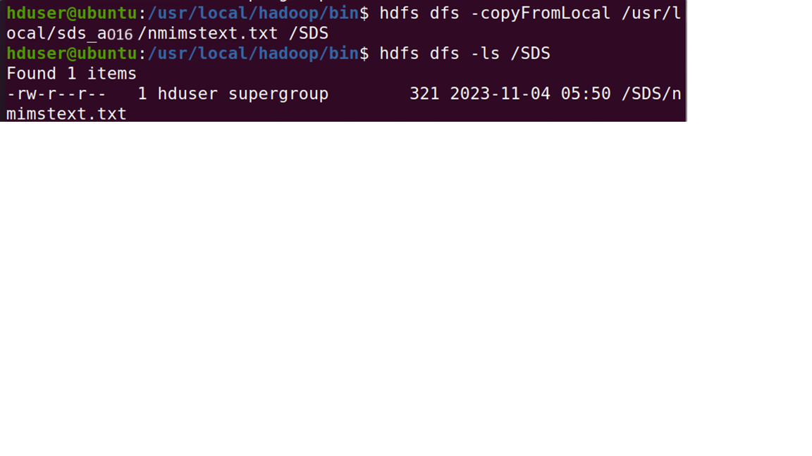

1. **Read the contents of file nmimstext.txt from the HDFS location**

cd /home/udit

hdfs dfs -cat /SDS/nmimstext.txt

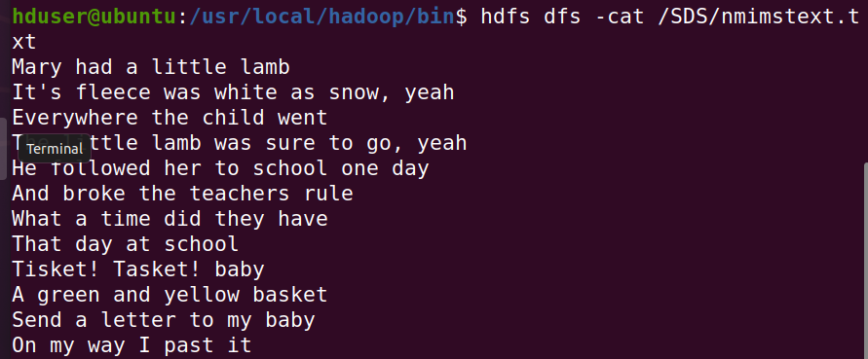

**Conclusion:** The practical to study File Management tasks in Hadoop File System was successfully executed.